**ENR 161 Fall 2017 Chapter 5 Homework**

Name _________________________________________________ Grade ______________

Step 1:

Watch the Video Entitled, **Excel Ch05 HW F16**, this video is stored on the M drive at MCC or on youtube.com.

Step 2:

Complete the questions and problems below.

1. If you have defined two matrices A and B, list the steps for computing the sum using Array Math.

2. In order to multiply two matrices together, such as A*B, what must be true? If the matrices can be multiplied together, how large will the product matrix be?

3. If you multiply a 3x3 matrix by its inverse what is the result? What is this product matrix called?

4. If you multiply a matrix by its identity matrix what is the result?

5. List the steps for solving a set of simultaneous equations using matices.

**Grade for Questions (0-10)** ______________________

**Problem Stamp or Grade**

**Pages 225-229, Addition Worksheet _________**_____________

1. Complete the operations presented in Figures 5.1 to 5.8 in one worksheet. **For all matrices in this assignment, center the elements of each matrix and add left and right borders. In addition, name each matrix using the Formula/Define Name tool so that the names have a scope of only the current worksheet.**

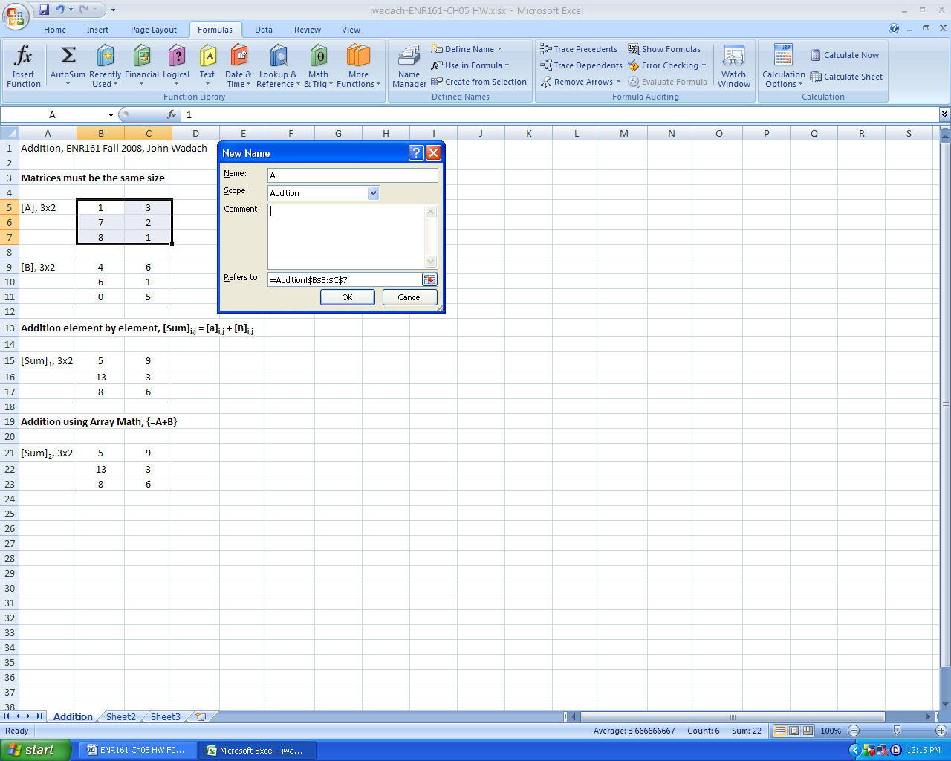

2. Add the labels as shown below on the next page.

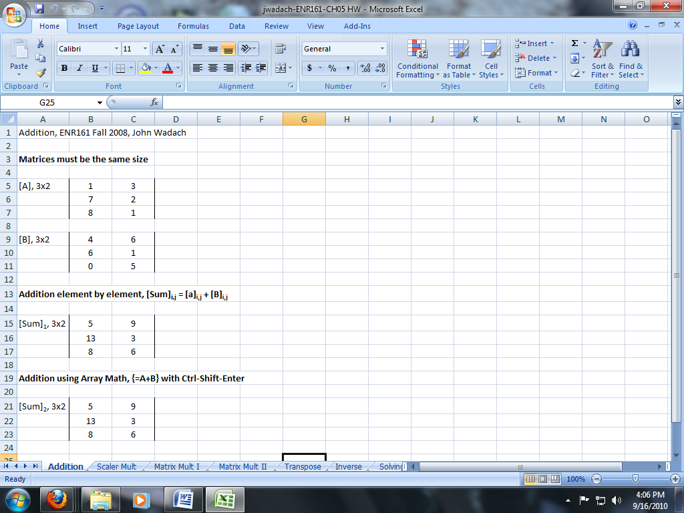

**Pages 229-231, Scalar Mult Worksheet _________**_____________

1. Complete the operations presented in Figures 5.9 to 5.13 in one worksheet.

2. Format your worksheet as shown below.

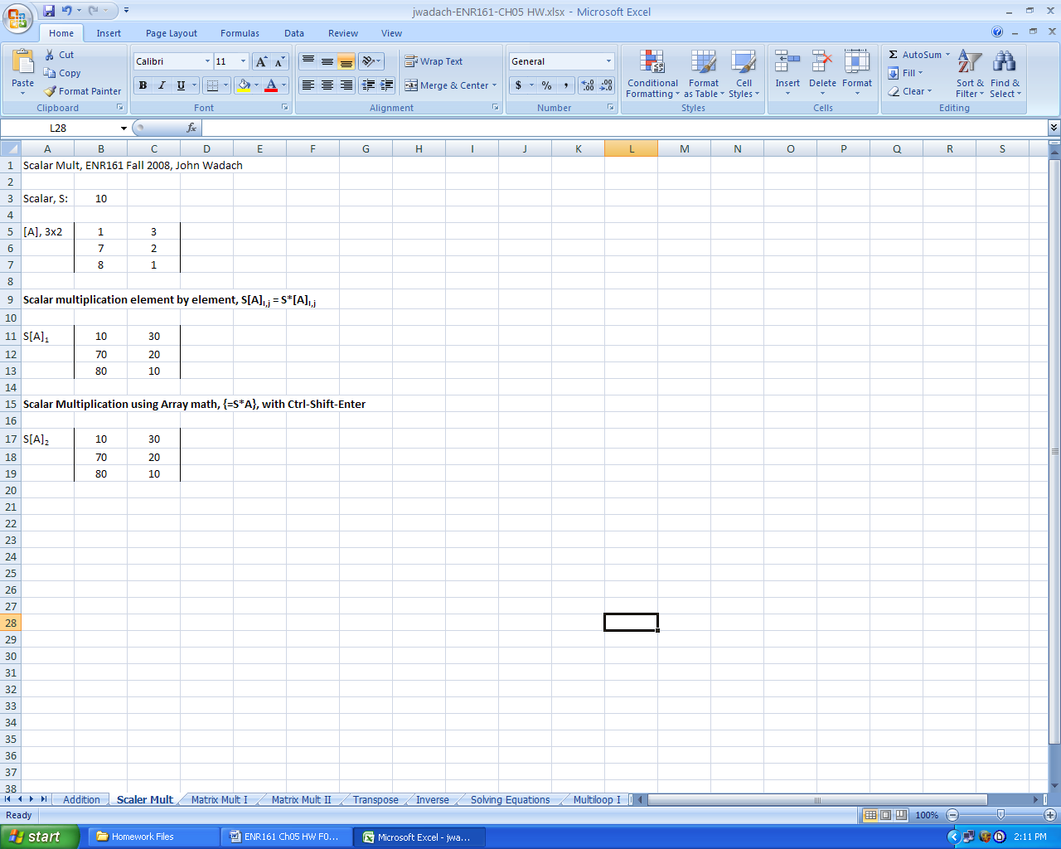

**Pages 231-234, Matrix Mult I Worksheet _________**_____________

1. Complete the operations presented in Figures 5.14 to 5.18 in one worksheet.

2. Format your worksheet as shown below.

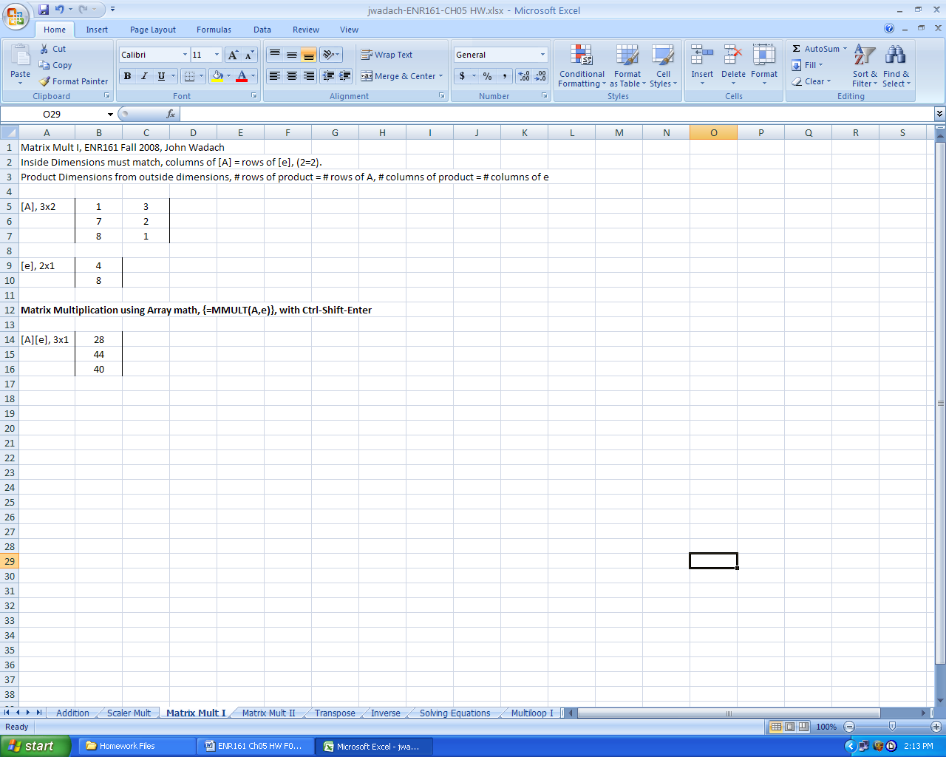

**Pages 234-235, Matrix Mult II Worksheet _________**_____________

1. Complete the operations presented in example 5.1.

2. Format your worksheet as shown below.

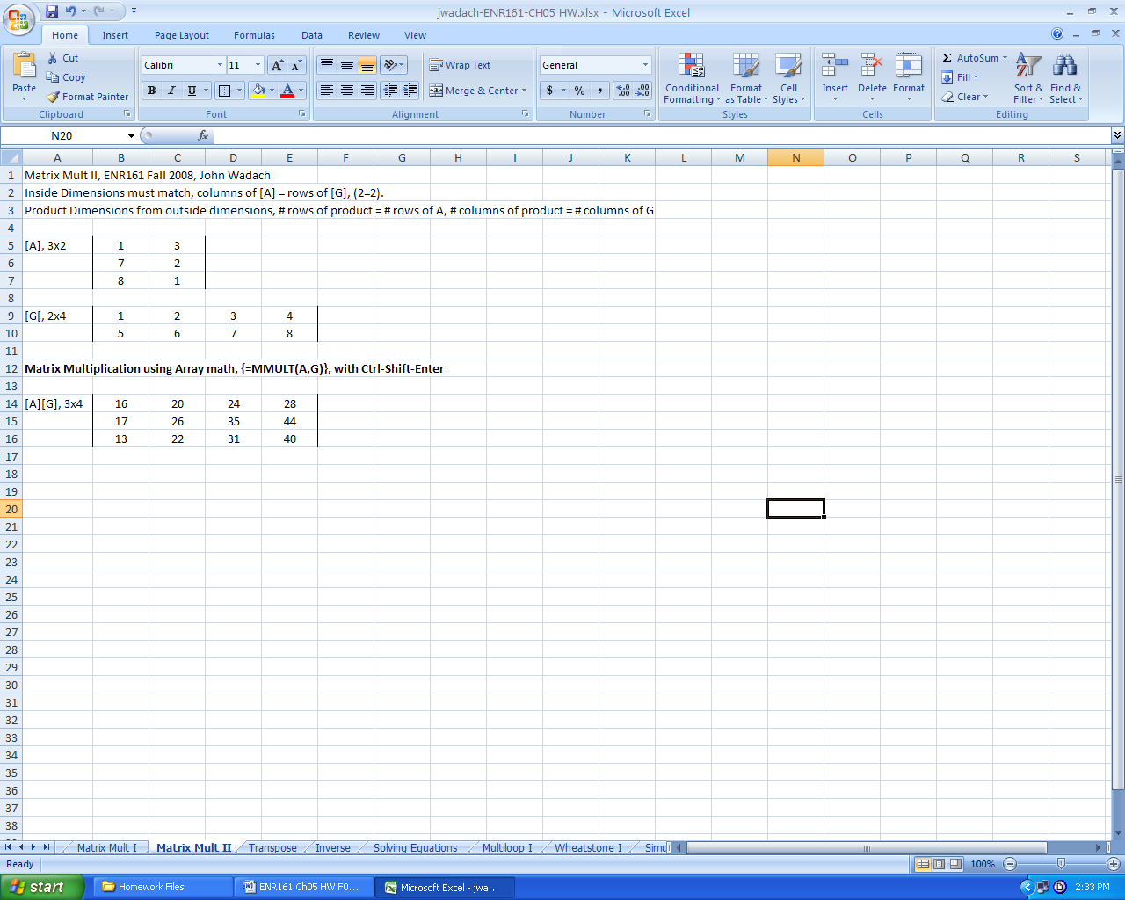

**Pages 235-237, Transpose Worksheet _________**_____________

1. Complete the operations presented in example figures 5.20 to 5.23 but also transpose the matrix using the Copy/Paste method.

2. Format your worksheet as shown below.

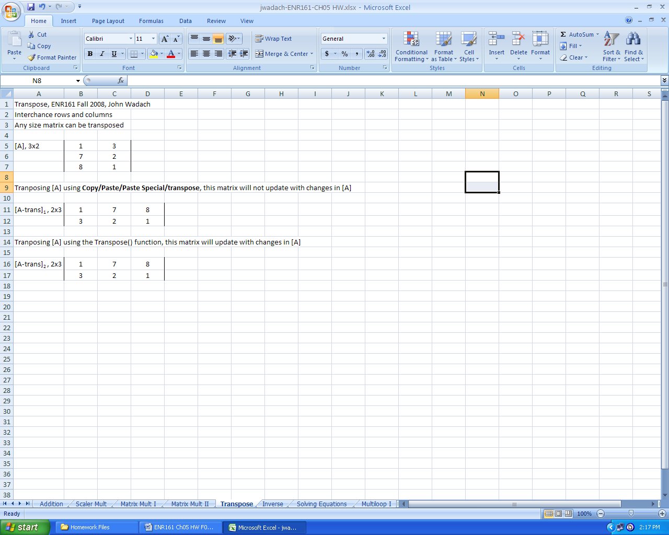

**Pages 237-239, Inverse Worksheet _________**_____________

1. Complete the operations presented in Figures 5.24 to 5.28 in one worksheet.

2. Compute the Identity Matrix, I, and the product of J*I. Format your worksheet as shown below.

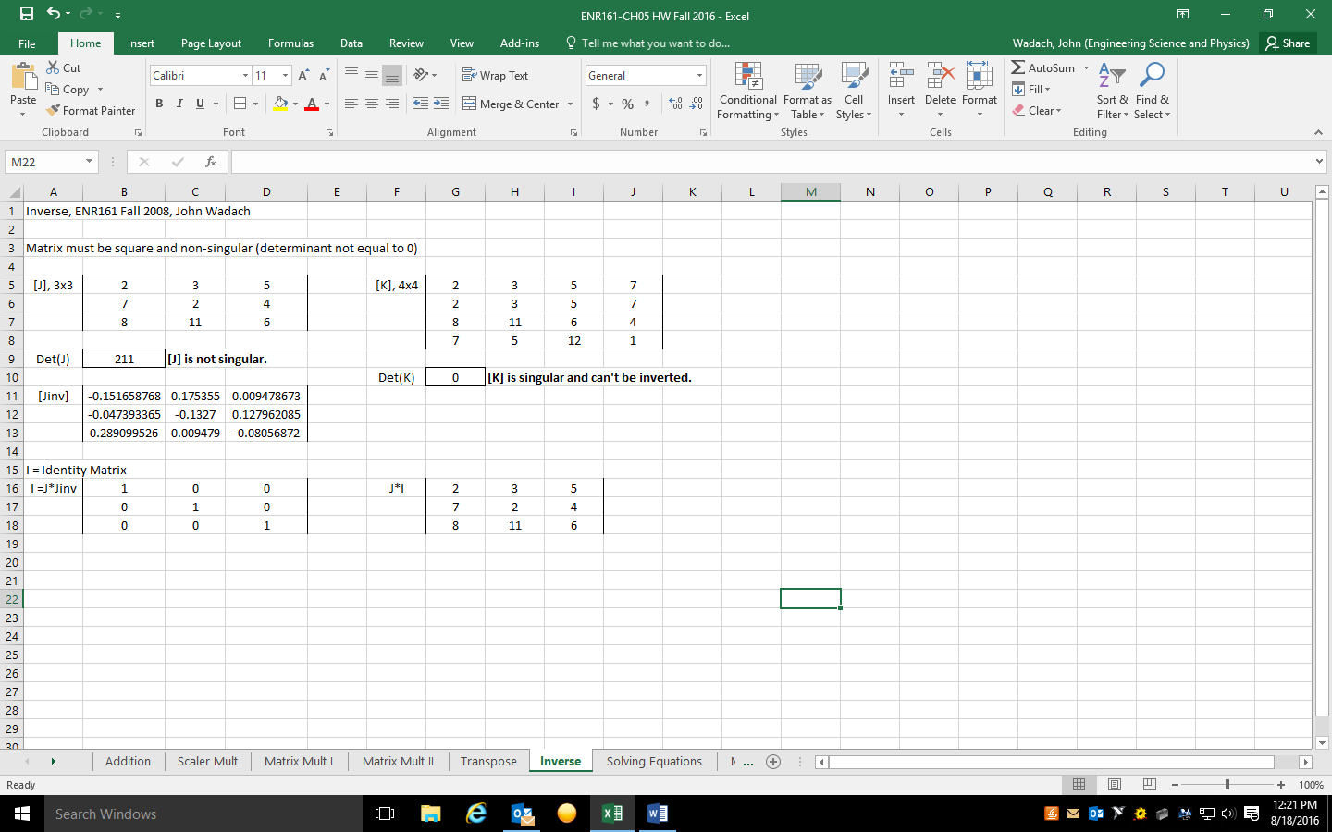

**Pages 240-242, Solving Equations Worksheet _________**_____________

1. Complete the operations presented in Figures 5.29 to 5.31 in one worksheet.

2. Compute the product of [Coeff]*[Coeff-inv] to show it is equal to the identity matrix.

3. Format your worksheet as shown below.

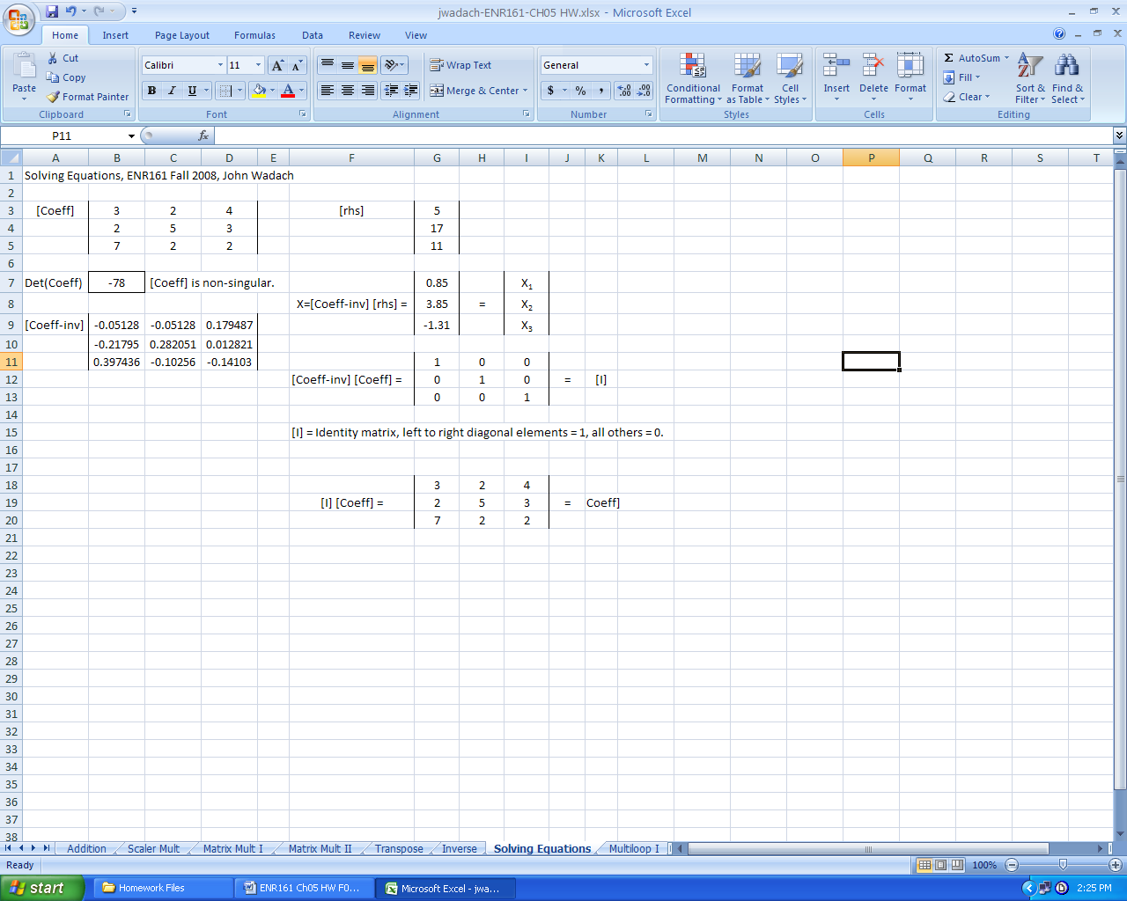

**Pages 242-244, Multiloop I Worksheet _________**_____________

1. Complete the operations presented in Figures 5.32 to 5.36 in one worksheet.

2. Name cells, use formulas in the matrices, and format the sheet as shown below.

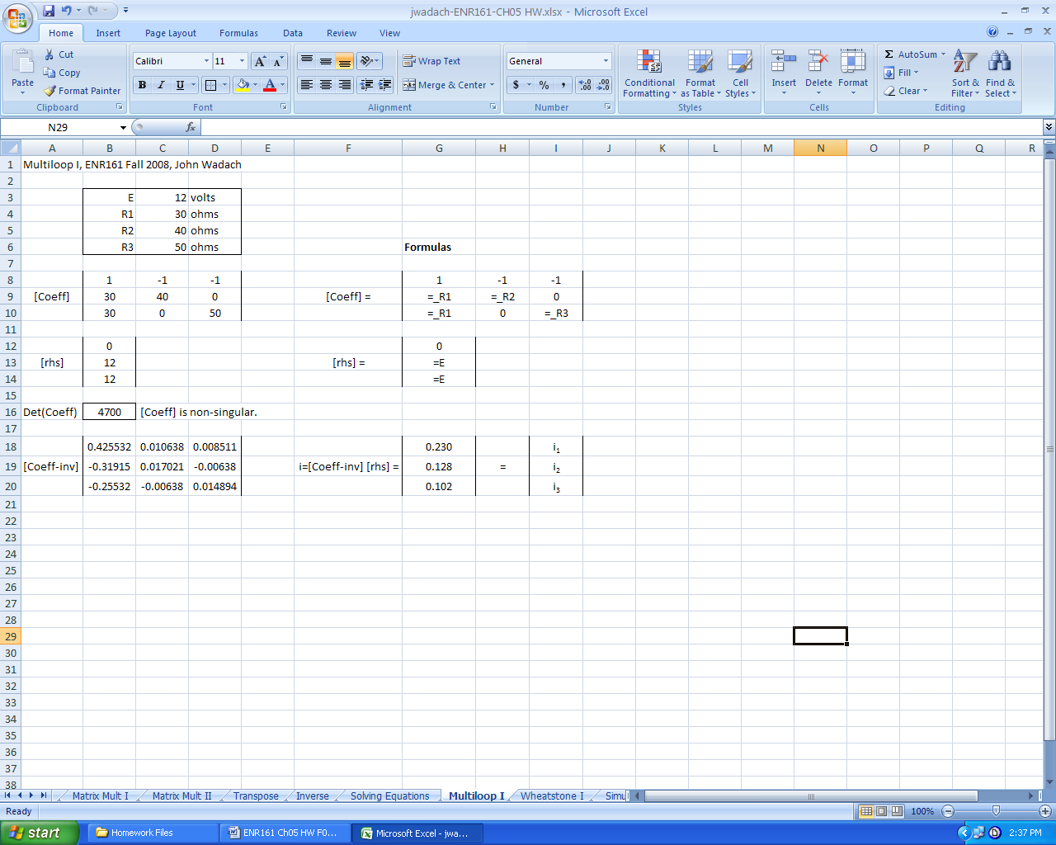

**Pages 245-247, Wheatstone I Worksheet _________**_____________

1. Complete the operations presented in Figures 5.37 to 5.41 in one worksheet.

2. Name cells, use formulas in the matrices, and format the sheet as shown below.

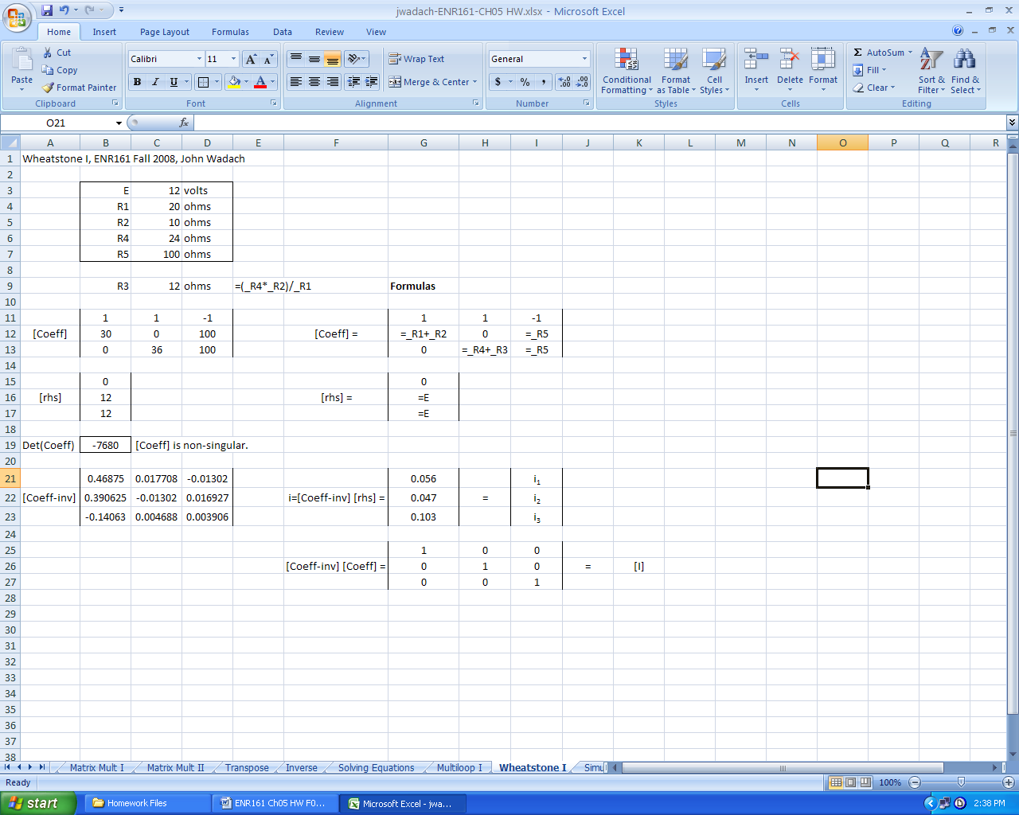

**Page 254, Simultaneous IIa Worksheet _________**_____________

1. Complete problem 5.2a but also solve for the unknowns (if possible).

2. Format your worksheet as was done for the **Solving Equations** worksheet.

**Page 254, Simultaneous IIIa Worksheet _________**_____________

1. Complete problem 5.3a.

2. Format your worksheet as was done for the **Solving Equations** worksheet.

**Page 254, Simultaneous IIIc Worksheet _________**_____________

1. Complete problem 5.3c.

2. Format your worksheet as was done for the **Solving Equations** worksheet.

**Page 254, Multiloop II Worksheet _________**_____________

1. Complete problem 5.4 but note that the resistor labeled R5 in the table should be R3.

2. Format your worksheet as was done for the **Multiloop I** worksheet.

3. Notice that using named cells and formulas in the **Multiloop I** makesthis worksheet easy.

**Pages 257-258, Wheatstone II Worksheet _________**_____________

1. Complete problem 5.8. Note that both R1 and R2 are both 15 ohms and that formula 5.19 is not needed to solve either part a or b of this problem.

2. Format your worksheet as was done for the **Wheatstone I** worksheet.

3. Notice that using named cells and formulas in the **Wheatstone I** makesthis worksheet easy.

**4. Note that R4 = 24 ohms as stated in part a of the problem.**